**PayMaster: Employee Management and Payroll System**

**Table of Contents**

1. Introduction

2. System Requirements

3.Software Design Methodology

4. System Features

5. Database Design

6. User Interface

7. Functionalities

8. Security Measures

9. Installation & Setup

10. Key VB.NET Classes

11. Audit Trail Mechanism

12. Troubleshooting

13. Future Enhancements

14. Conclusion

15. Link to GitHub Repository

**1. Introduction**

PayMaster is a desktop-based employee management and payroll system developed using VB.NET and SQL Server. It enables administrators to manage employee records and automate salary calculations including tax deductions and net pay. The system enhances efficiency and ensures data integrity through user authentication and an easy-to-use graphical interface.

**2. System Requirements**

**Hardware Requirements:**

- Processor: Intel Core i3 or higher

- RAM: 4GB or more

- Hard Disk: 2GB free space minimum

**Software Requirements:**

- Windows OS (Windows 7 or later)

- VB.NET Framework

- Microsoft SQL Server (2016 or later)

- Visual Studio (2019 or later)

**3. Software Design Methology**

This methodology was used for the project. This is because it had well-defined, unchanging requirements and clear deliverables, and since the project was small and less complex, this methodology was ideal.

**4. System Features**

- User Authentication

- Dashboard with access to key modules

- Employee Management (CRUD + photo upload)

- Payroll Reporting with breakdown

- Export/Generate Payroll reports

**5. Database Design**

**Users Table:**

CREATE TABLE Users (

UserID INT IDENTITY(1,1) PRIMARY KEY,

Username NVARCHAR(20) NOT NULL UNIQUE,

PasswordHash NVARCHAR(100) NOT NULL,

CreatedAt DATETIME DEFAULT GETDATE()

);

**Employees Table:**

CREATE TABLE Employees (

EmployeeID INT IDENTITY(1,1) PRIMARY KEY,

Firstname NVARCHAR(50),

Surname NVARCHAR(50),

Gender NVARCHAR(10),

Phone NVARCHAR(15) UNIQUE,

Address NVARCHAR(255),

Position NVARCHAR(100),

Status VARCHAR(10),

Picture VARBINARY(MAX),

Salary DECIMAL(10,2),

InsertDate DATETIME DEFAULT GETDATE(),

UpdateDate DATETIME,

DeleteDate DATETIME

);

**6. User Interface**

**Login Form**

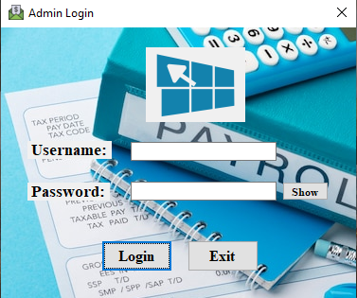

A Login form for PayMaster with Username and Password fields

**Dashboard (Main Menu) Form**

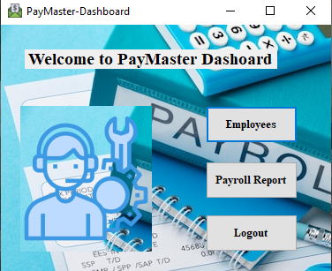

A clear Admin dashboard with quick access to Employees and Payroll Report

**Employees Management Dashboard Form**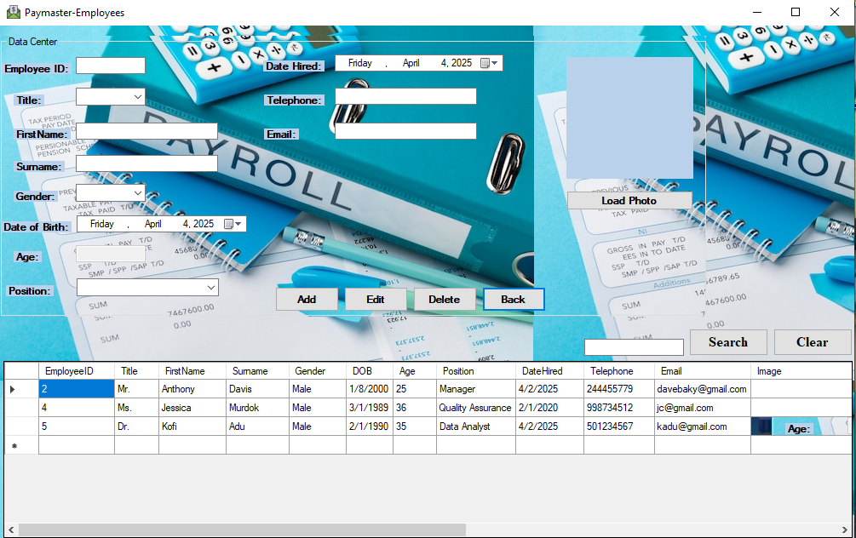

This form allows Admin to view, add, search and update employee records

**Payroll Form**

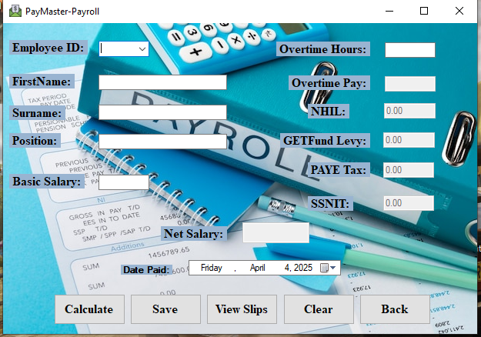

Payroll processing form with salary calculations, deductions, and payment functions

**Payroll Dashboard**

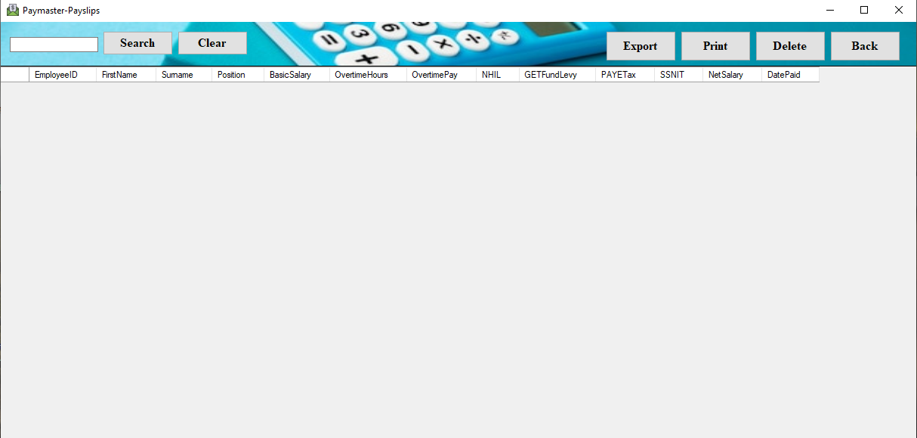

This form displays employee payroll data with search, export, delete and print tools and columns for earnings, deductions and payment details

**7. Functionalities**

- Secure login

- Employee CRUD (Create, Read, Update and Delete) operations

- Payroll calculation

- Report generation

- Picture upload

**8.Security Measures**

- Encrypted password storage

- Admin-only login

- Data validation

**9. Installation & Setup**

1. Install Visual Studio and SQL Server

2. Create database and run scripts

3. Configure connection string

4. Run the application

**10. Key VB.NET Classes**

- Login.vb

- Dashboard.vb

- Employees.vb

- Payroll.vb

- DBConnection.vb

**11. Audit Trail Mechanism**

The system logs InsertDate, UpdateDate, and DeleteDate for employee records to maintain audit history.

**12. Troubleshooting**

Login issues → Check credentials

Image not uploading → Check file size

Salary errors → Validate Employee ID

**13. Future Enhancements**

- Role-based access control

- Password recovery

- Monthly analytics

**14. Conclusion**

PayMaster offers an efficient and reliable way to manage employees and payroll with easy navigation and robust backend logic.

**15. Link to GitHub Repository**

https://github.com/Devffrey14/PayrollSystem.git